**Aim:**

**To design an InternTrack Full Stack Web Application.**

**Design - Used elements:**

**Index.html**

* <h2>: Displays the welcome message.
* <p>: Provides a short instruction about login options.

Buttons (Login Options):

* Anchor (<a>) tags styled as buttons for navigation to different login pages:
  + Student Login (student.html)
  + Coordinator Login (coordinator.html)
* Uses class="login-button" for styling, including padding, background color, and hover effects.

Container Design:

* A <div class="home-container"> wraps the content to create a centered, card-like design.

**Student.html**

Form (<form>) for Student Login:

* Uses the GET method to send form data to form.html.

Form Elements Used:

* Text Input (<input type="text">)
  + Register Number Field: Requires the student to enter their registration number.
* Dropdown Selections (<select> with <option>)
  + Degree Dropdown: Options include BE, ME, and MTech.
  + Batch Dropdown: Allows selection of different student batches (e.g., 2021-2025, 2022-2026).
  + Academic Year Dropdown: Provides year options from 2021-2028.
  + Year of Study Dropdown: Allows selection from I to IV (First to Fourth Year).
* Submit Button (<button type="submit">)
  + Submits the form data when clicked.

Form Design (<div class="form-group"> for Structuring)

* Each input field and dropdown is wrapped in a <div class="form-group"> for better organization.

**Form.html**

Form Input Fields

* Register Number & Name
* Internship Title
* Mobile Number
* Section
* Internship Obtained (Yes/No) - Radio Button
* Internship Period & Dates
* Company Name
* Placement Source (Dropdown)
* Stipend (Numeric Input)
* Internship Type (Dropdown: Research, Industry, Academic)
* Internship Location (Abroad/India - Radio Button)
* Document Submission (Multiple Checkboxes)

Form Enhancements

* Pre-filled Data Handling: Uses URLSearchParams to populate fields dynamically if provided via URL.
* Footer Buttons: Start, Save, Verify, and End for additional control.
* JavaScript for Pre-filling: Automatically populates form fields if query parameters exist.
* CSS External File: from.css is used for styling.

**Final.html**

This creates a table and fill the table when previous form.html is submitted. It uses JavaScript to do this.

**Coordinator.html**

Similar to student.html but it does not include inputting the register number and upon submitting, it redirects to the staff dashboard page where the coordinator can select a query and get the necessary details what executes query using Google drive as the backend.

**Staff-dashboard.html**

A staff dashboard with buttons for filtering internship-related data and a dynamic display area to show the results is created.

Structural Elements:

* <div> – Used to group and structure content, such as the dashboard container, button group, and list display area.
* <h2> and <h3> – Headings used to display the dashboard title and dynamic list titles.
* <ul> and <li> – Used to create an unordered list for displaying student names dynamically.

Input & Interactive Elements:

* <button> – Used for different types of internship filtering (e.g., batch-wise, CDC-based, stipend-based, etc.).
* onclick Attribute – Attached to buttons for triggering JavaScript functions dynamically.

JavaScript-Based Dynamic Elements:

* Dynamic Content Manipulation – Uses document.createElement() to generate and display filtered lists.
* Data Filtering (Array.filter()) – Filters student data based on conditions like stipend, internship type, and location.
* Event Handling (onclick) – Listens for button clicks to trigger JavaScript functions.
* DOM Manipulation (appendChild()) – Appends generated elements like lists (ul, li) to the webpage.

External Resource Elements:

* <link rel="stylesheet" href="staff.css"> – Links an external CSS file for styling

**Also created necessary CSS files to style these web pages like student.css, staff.css, from.css, final.css.**

**Design with Output Screenshots:**

First of all, I have designed the login page which displays the choice for 2 logins, the student and the coordinator.

The file I have used for this is the index.html file. This file has two buttons for each login and upon clicking, it takes you to the corresponding login pages.

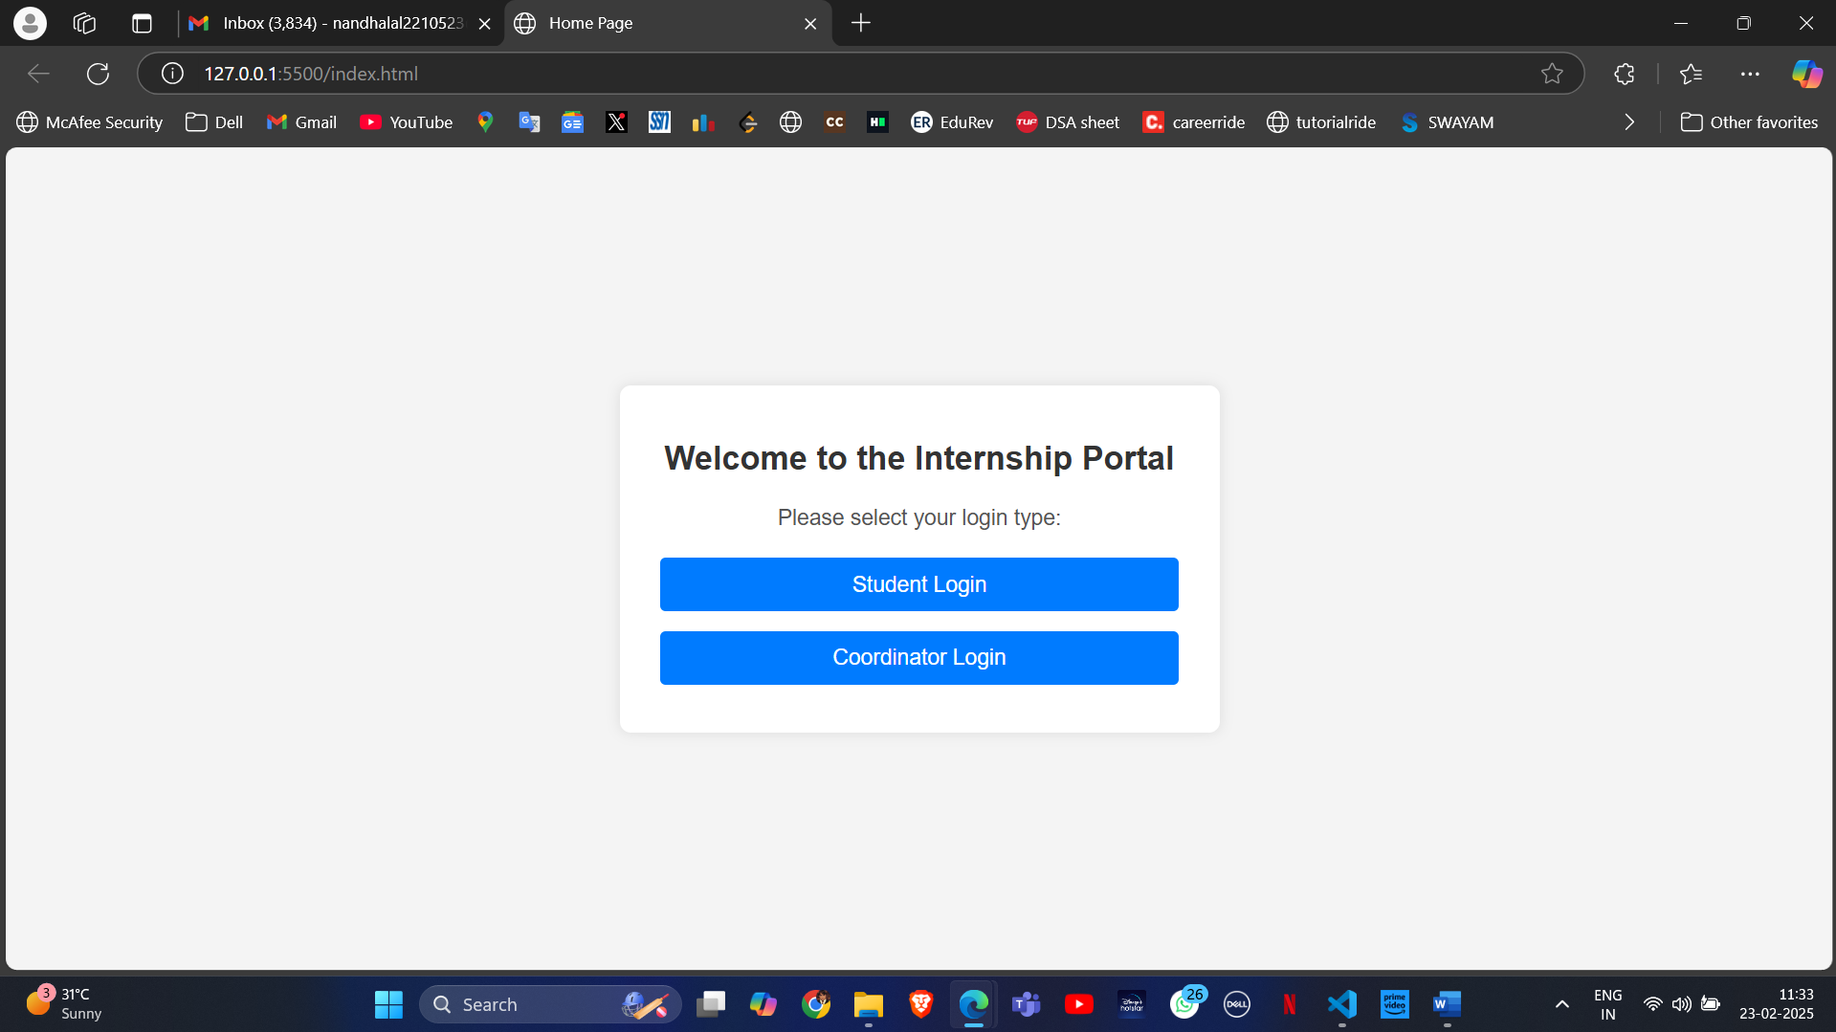

Now let us look into the Student login page. The student can login using his register number, degree type, batch, current academic year and the year of his study.

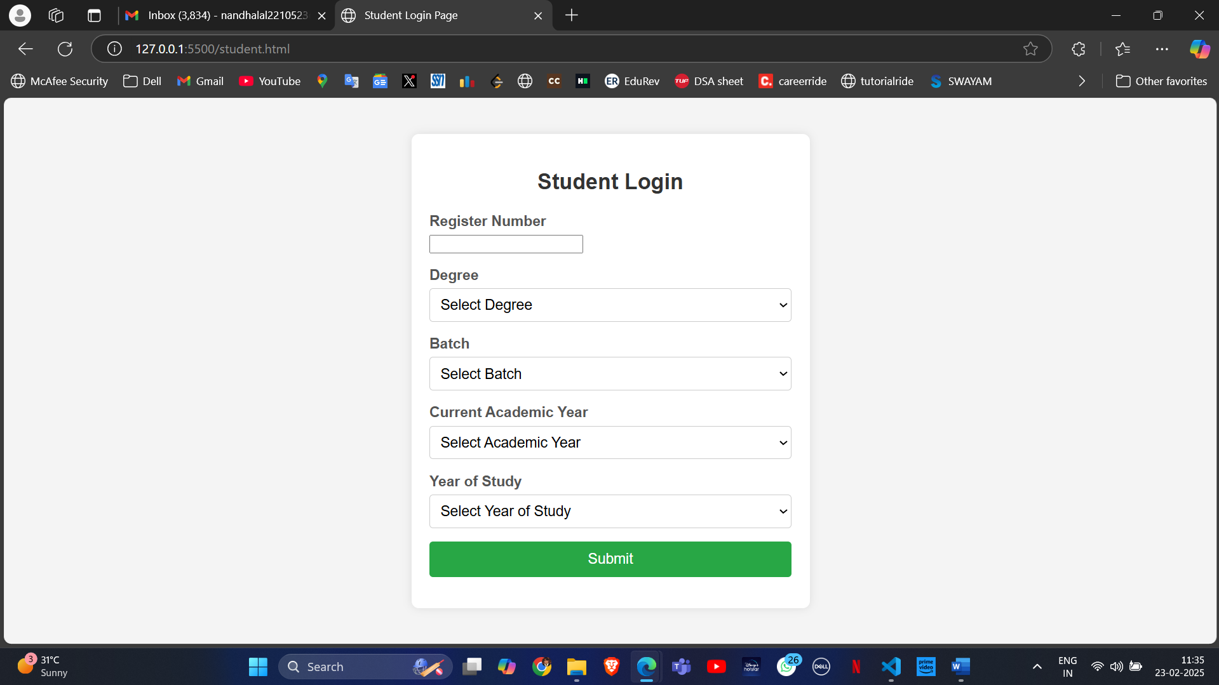

It also asks to fill out every field if you submit without filling out any field. This is done for all the subsequent pages too.

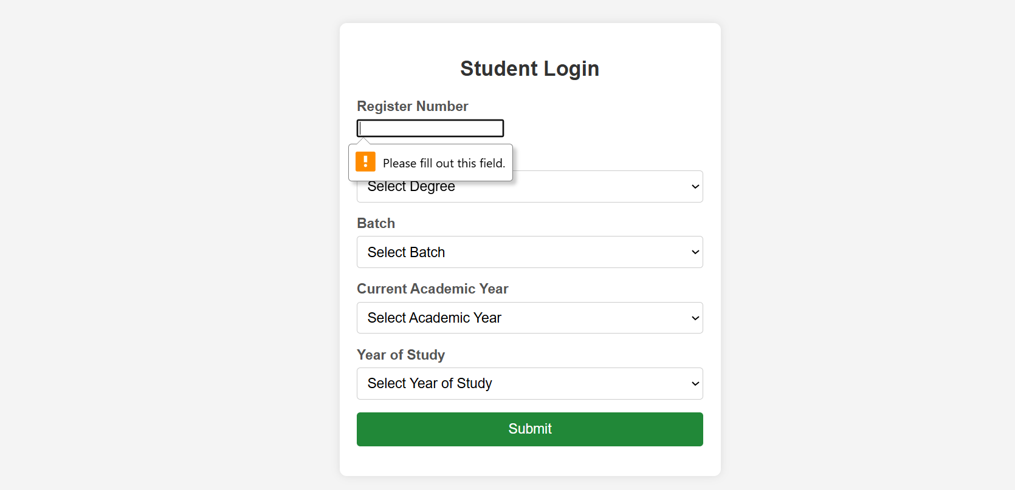

The selection types are given as below.

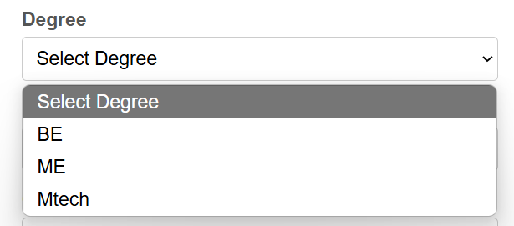 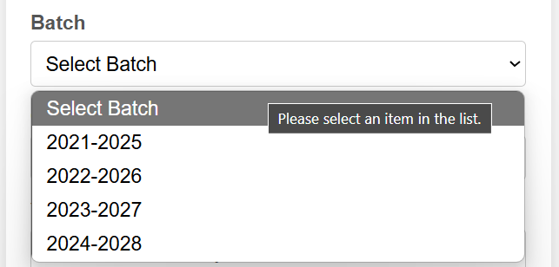

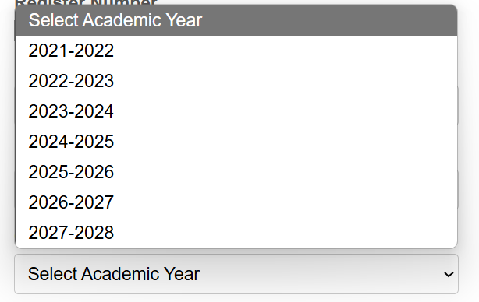 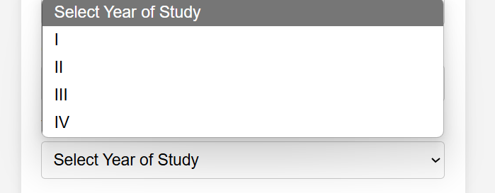

Sample filled up data:

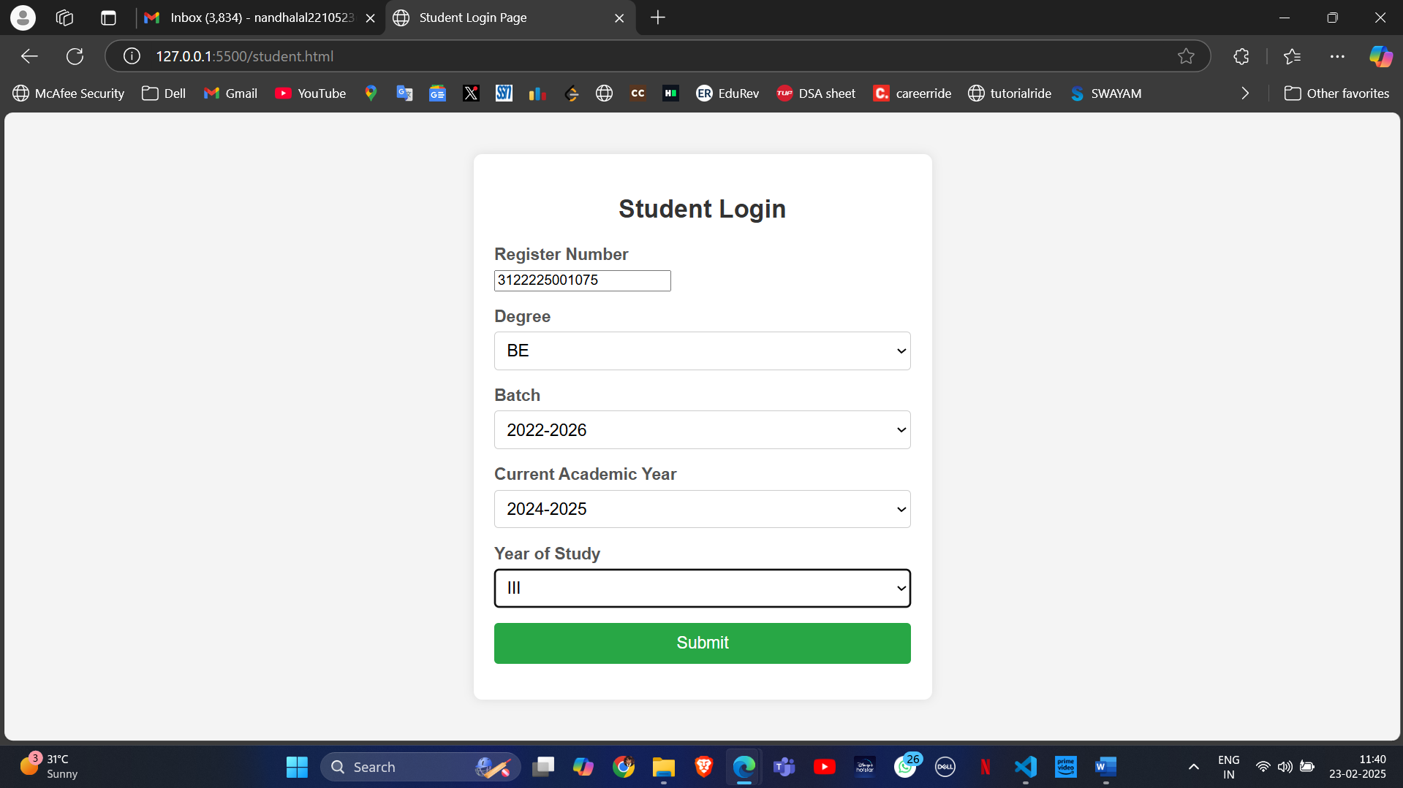

Upon clicking submit button, it takes you to the page where you can either edit or view your data.

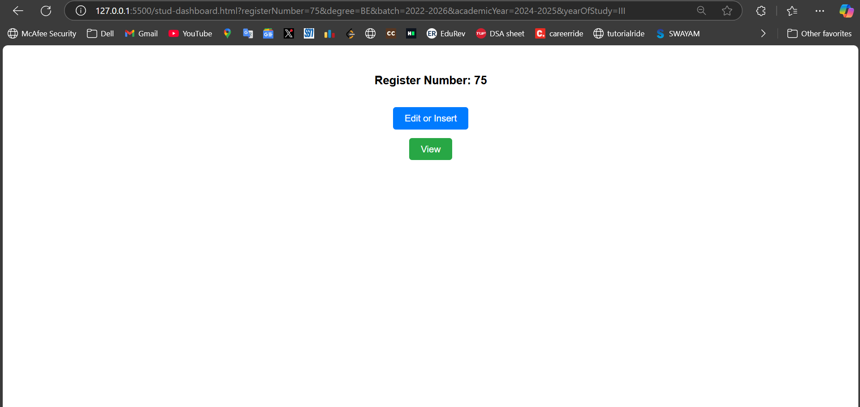

Edit or Insert takes you to the form.html page to insert new data. This data is updated in the csv file at the backend.

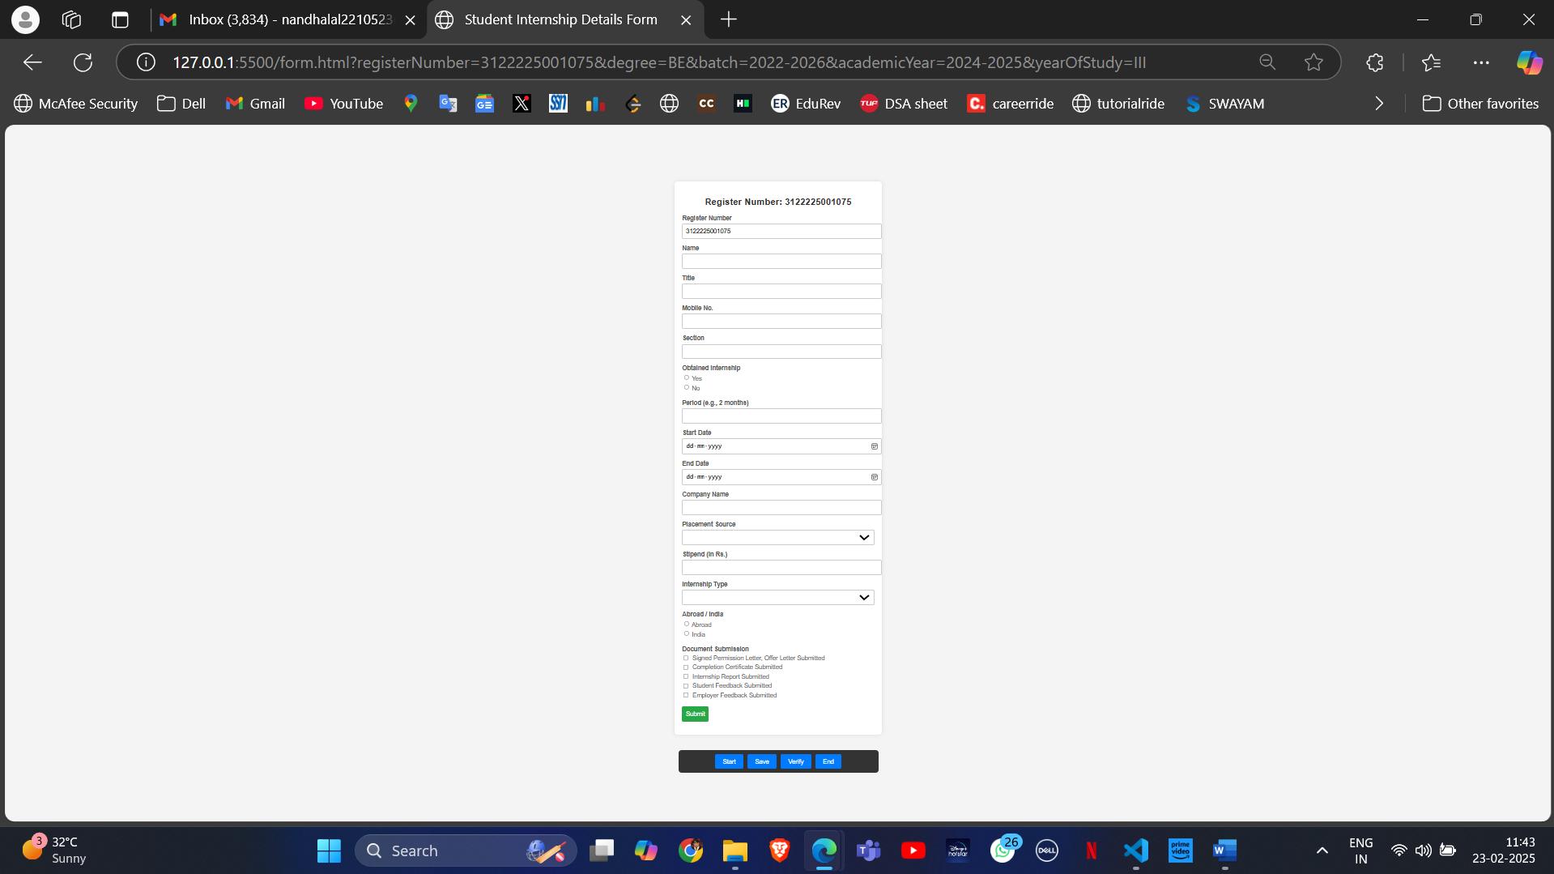

Attached the snapshots for all the fields done.

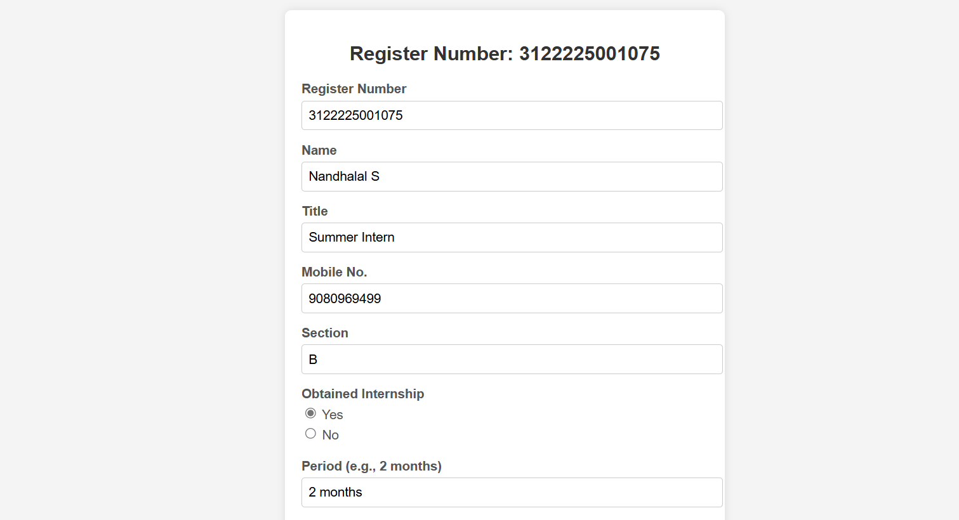

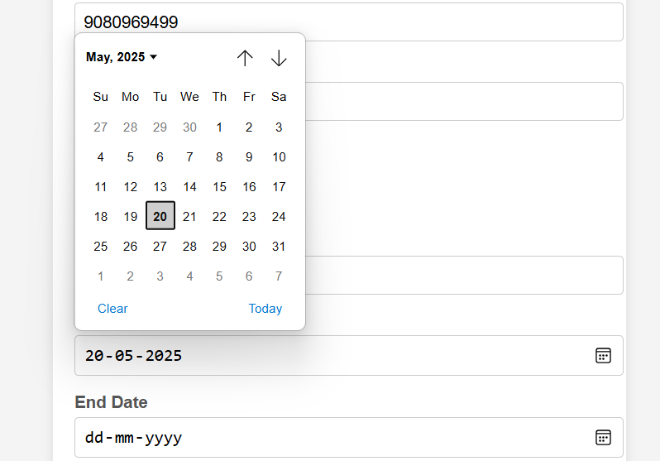 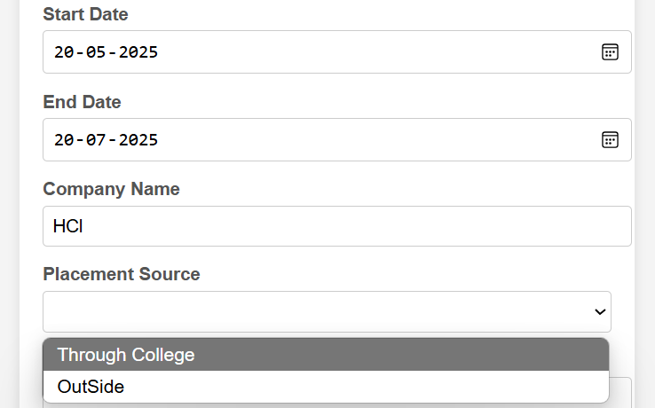

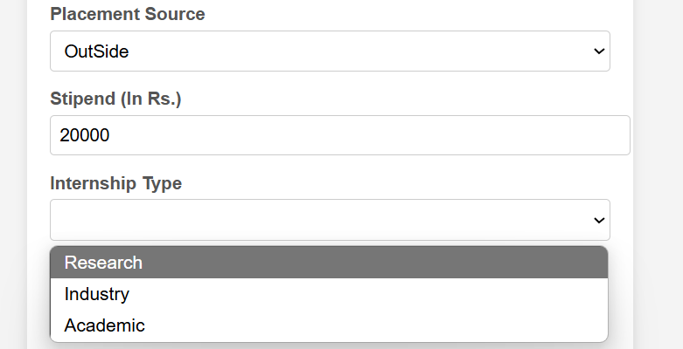

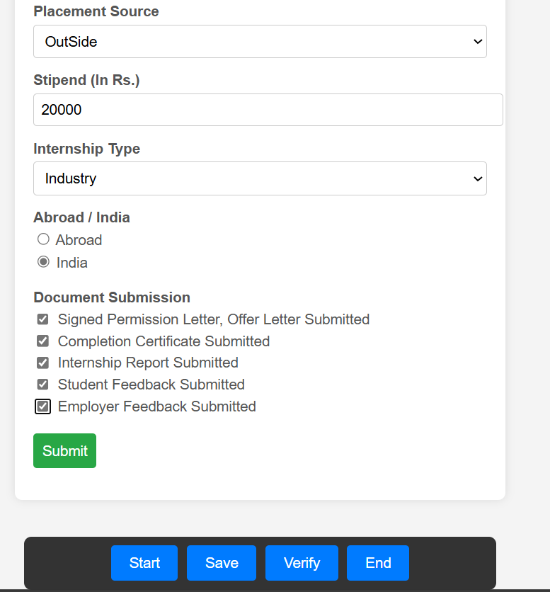

On clicking either submit or Save button, it shows all the details in a table which I have inputted in another page. Code for this is provided in final.html file.

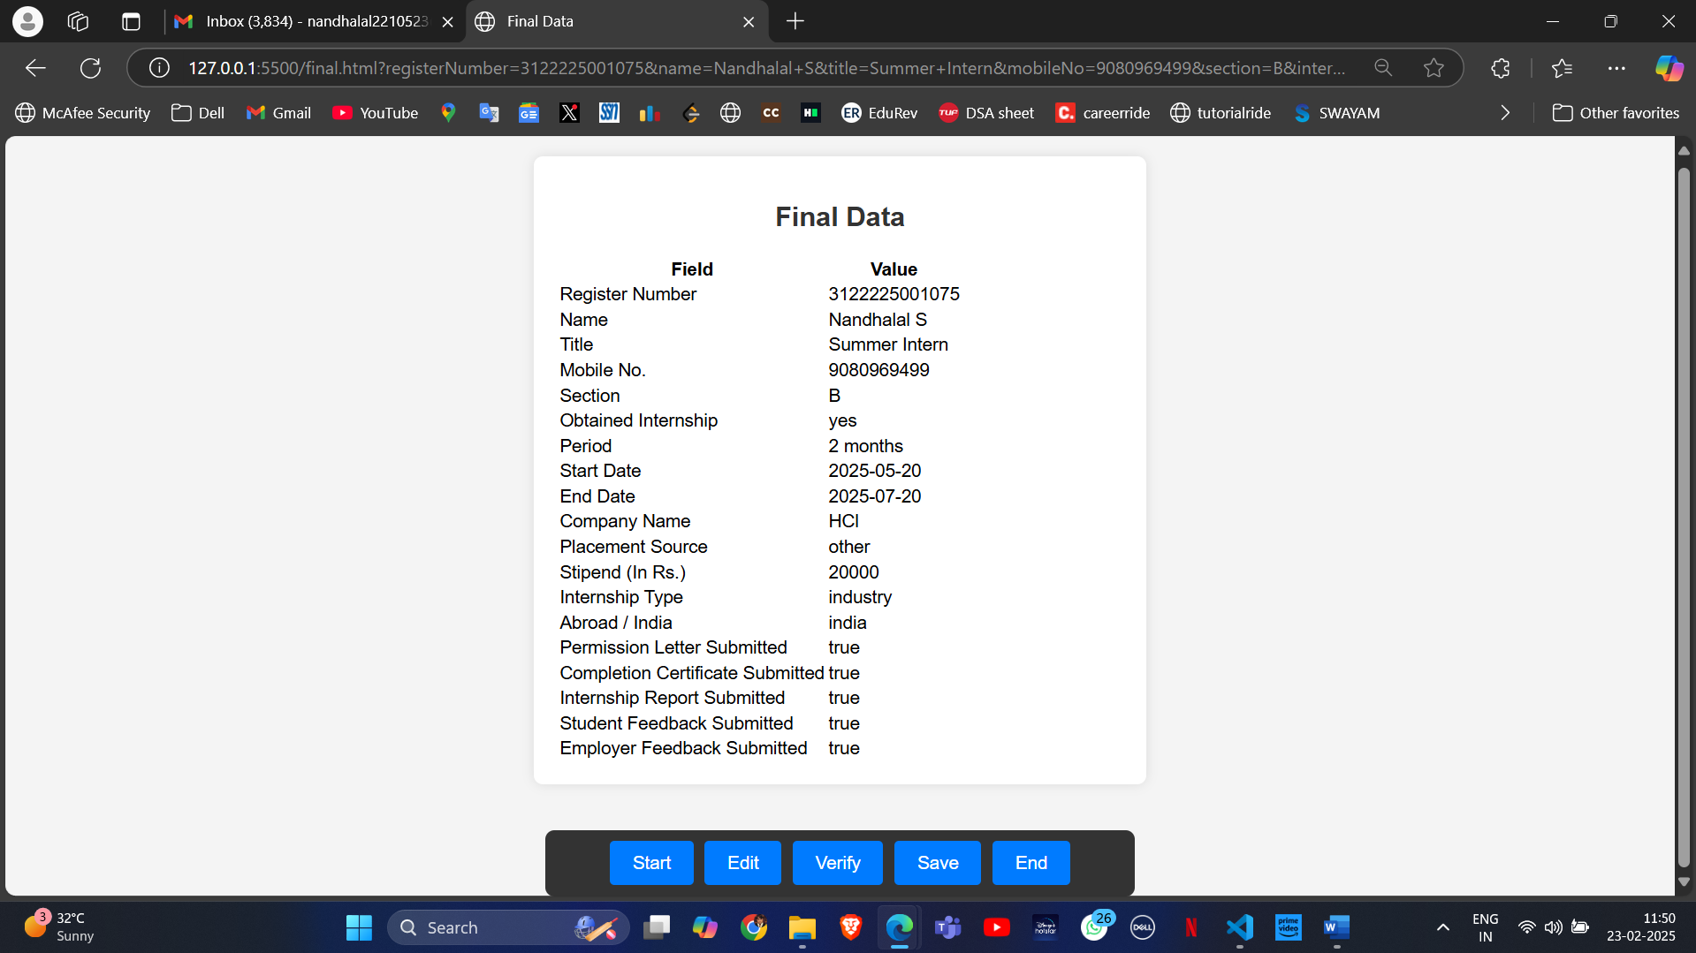

On clicking Edit button, it redirects to the form page to edit the details again, and if you click save, it once again displays the newly edited and saved info. It is updated in the original CSV file too which is in google drive that serves as Backend.

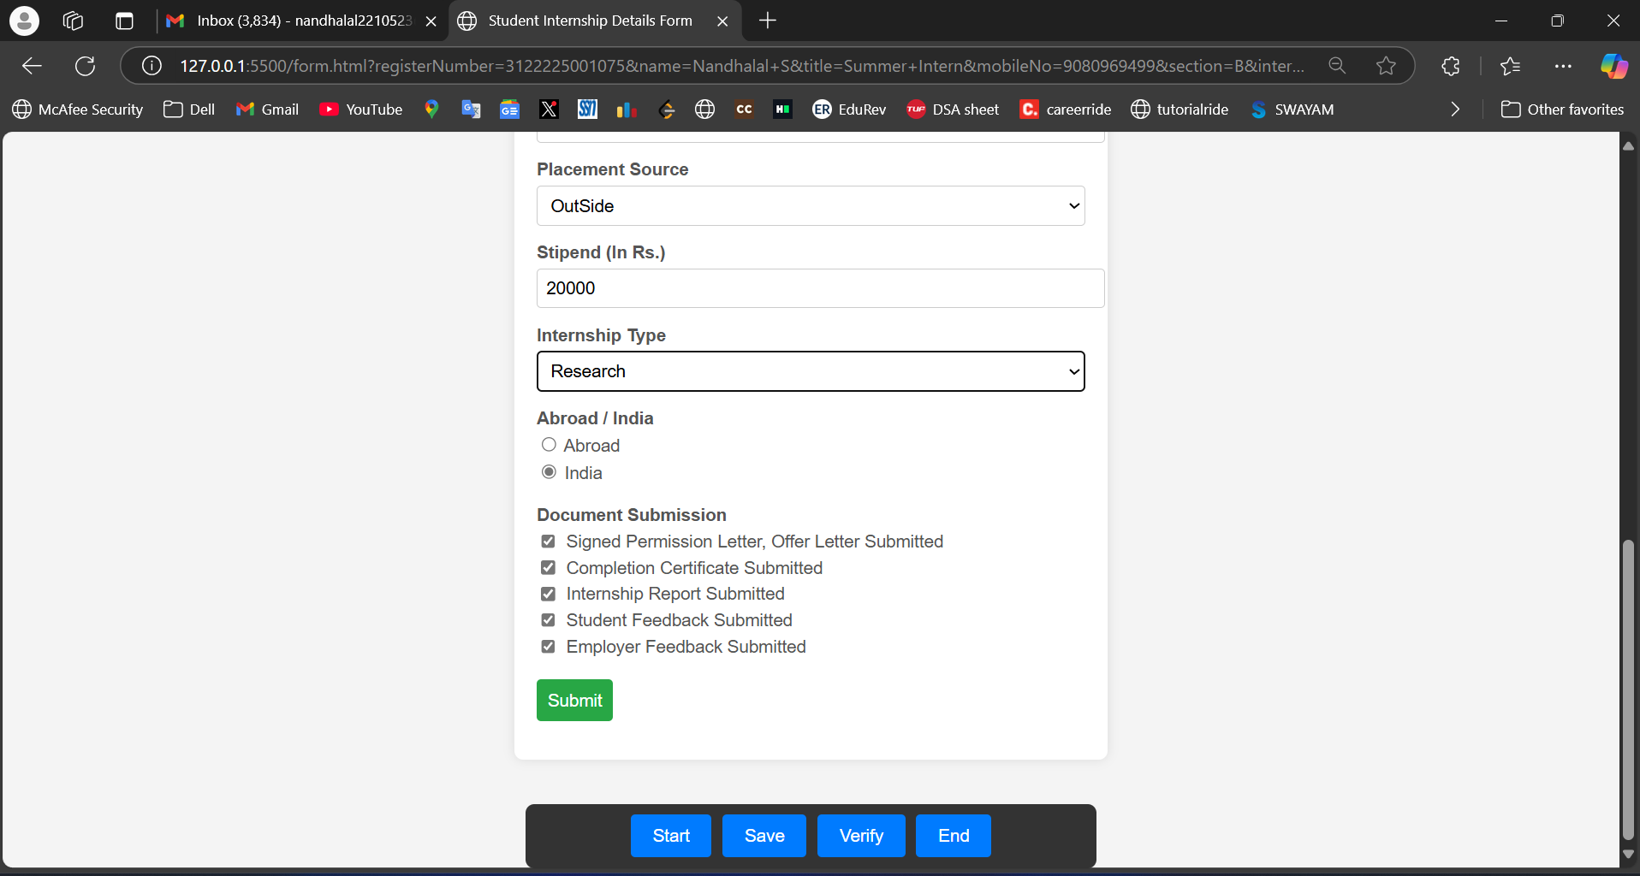

Internship type changed to Research and now clicking Save to show new updated data.

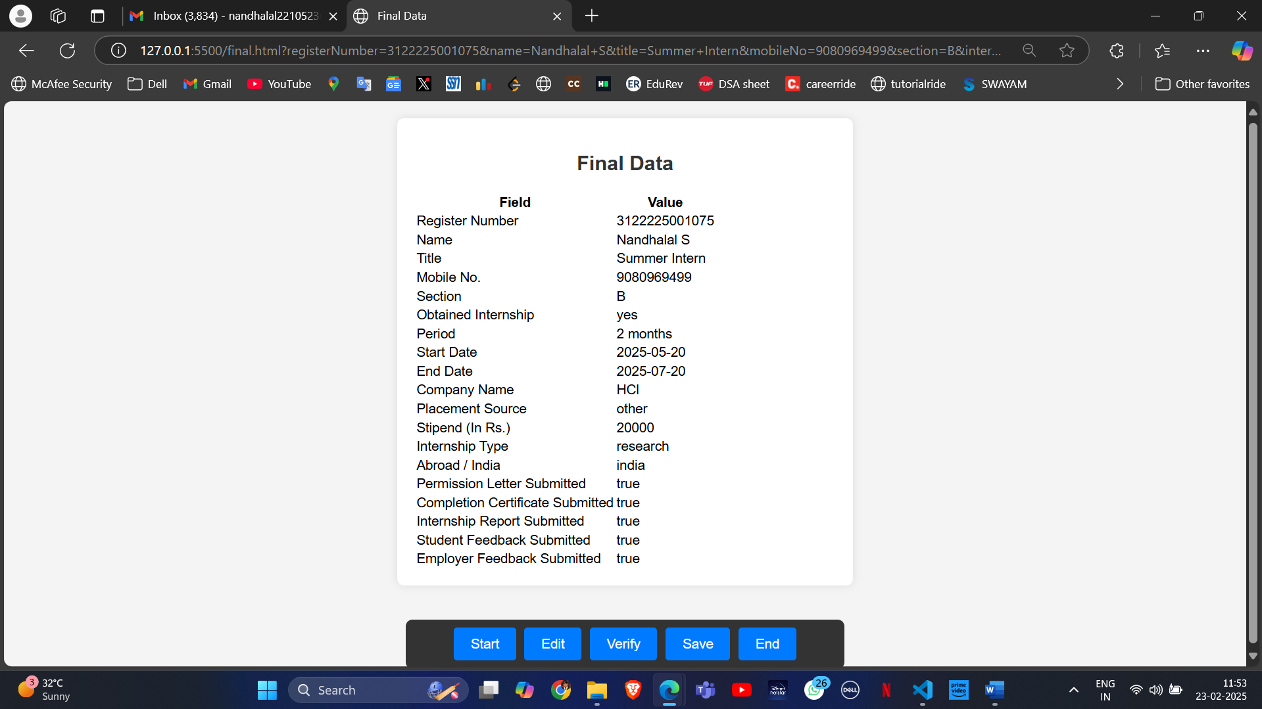

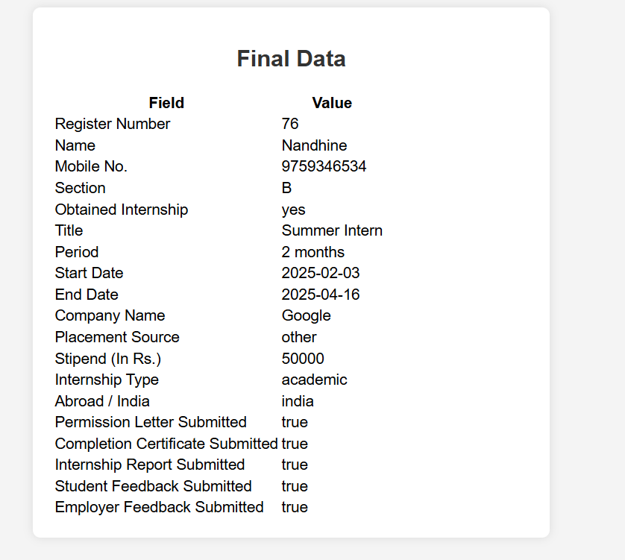 Inserting sample data

Updated in backend csv file

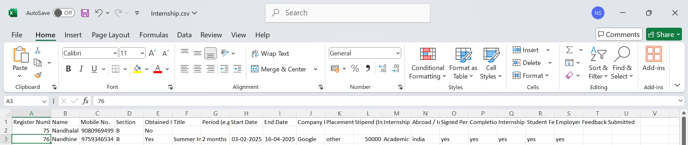

If you click the view button, it retrieves data from the csv file for the corresponding register number.

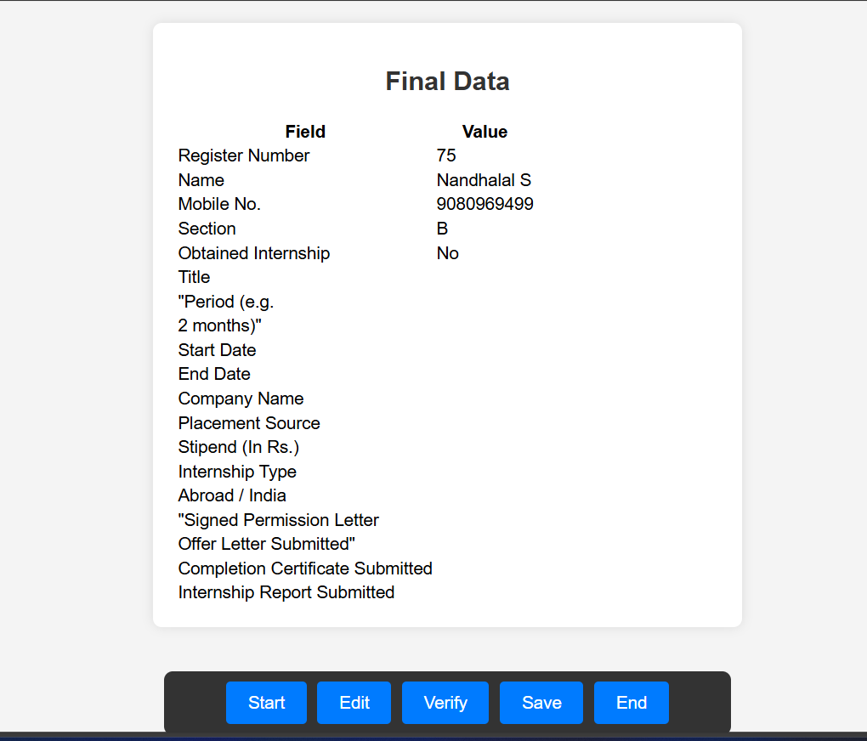

Now let’s see about the coordinator login page.

It is handled in coordinator.html file

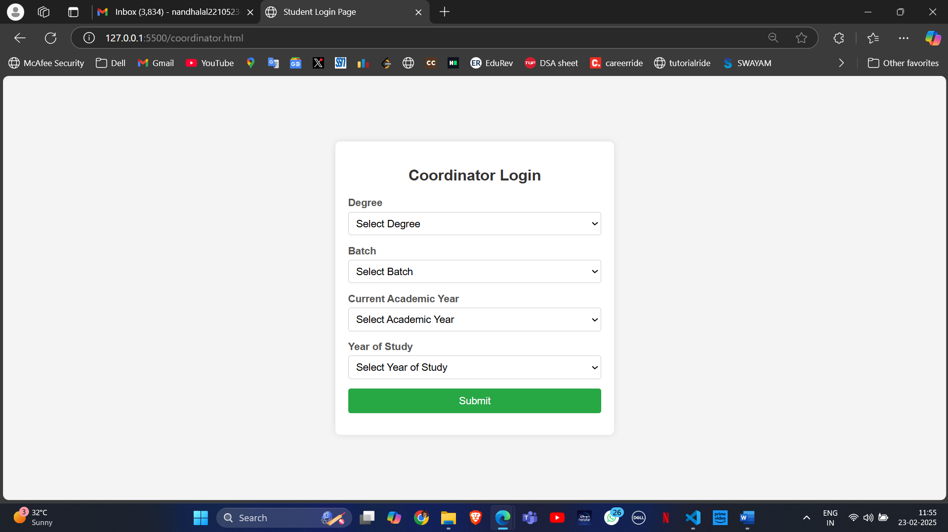

The coordinator can select the degree, batch, academic year and year of study to see the details of the students who studied in that particular batch, degree, academic year and year of study.

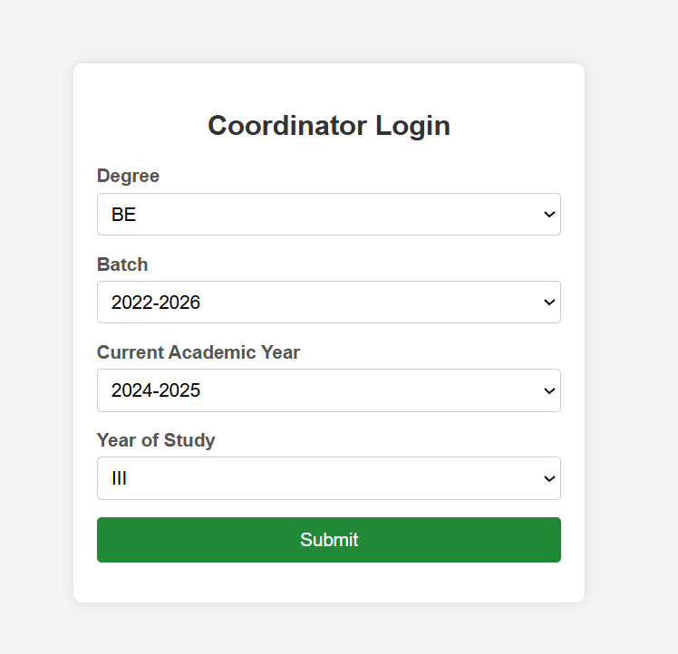

It takes you to the page of the dashboard where the coordinator(staff) can do all these operations.

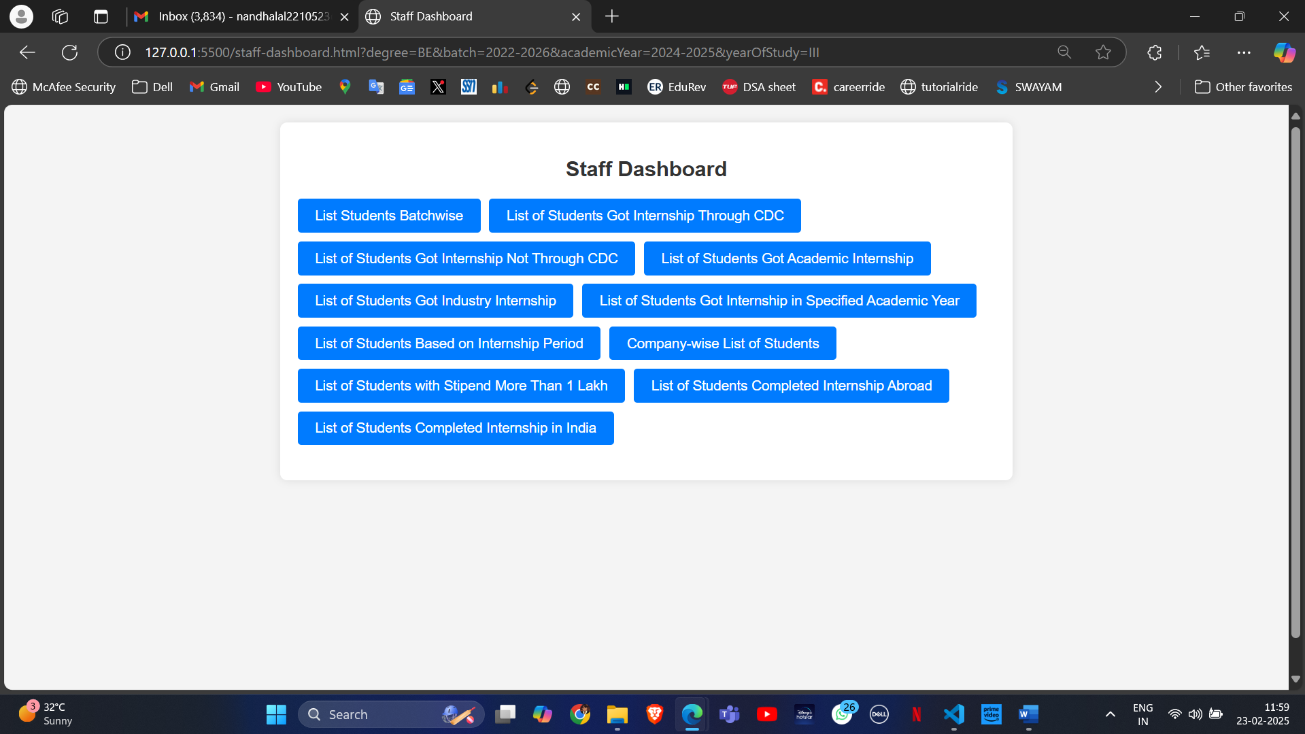

On clicking any of the query, it retrieves details of the students that matches the query. This can be done by keeping the Google drive as backend.

Example:

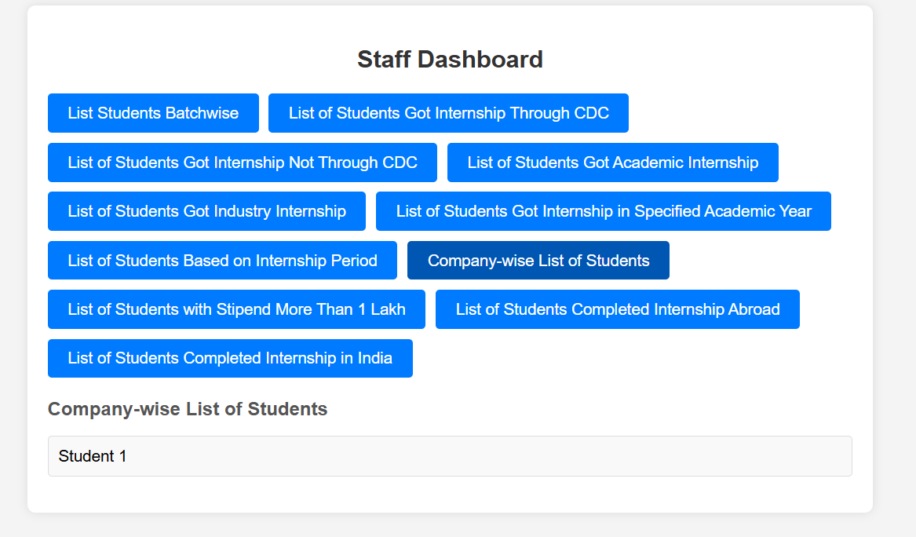

**Source code for the Frontend:**

**Index.html**

<!DOCTYPE html>

<html lang="en">

<head>

    <meta charset="UTF-8">

    <meta name="viewport" content="width=device-width, initial-scale=1.0">

    <title>Home Page</title>

    <style>/* styles.css */

        body {

            font-family: Arial, sans-serif;

            background-color: #f4f4f4;

            margin: 0;

            padding: 0;

            display: flex;

            justify-content: center;

            align-items: center;

            min-height: 100vh;

        }

        .home-container {

            background-color: #fff;

            padding: 20px;

            border-radius: 8px;

            box-shadow: 0 0 10px rgba(0, 0, 0, 0.1);

            width: 100%;

            max-width: 400px;

            text-align: center;

        }

        h2 {

            margin-bottom: 20px;

            color: #333;

        }

        p {

            margin-bottom: 20px;

            color: #555;

        }

        .button-group {

            margin-bottom: 15px;

        }

        .login-button {

            display: inline-block;

            width: 90%;

            padding: 10px;

            background-color: #007bff;

            color: white;

            text-decoration: none;

            border-radius: 4px;

            font-size: 16px;

            text-align: center;

            cursor: pointer;

        }

        .login-button:hover {

            background-color: #0056b3;

        }</style>

</head>

<body>

    <div class="home-container">

        <h2>Welcome to the Internship Portal</h2>

        <p>Please select your login type:</p>

        <!-- Button for Student Login -->

        <div class="button-group">

            <a href="student.html" class="login-button">Student Login</a>

        </div>

        <!-- Button for Staff Login -->

        <div class="button-group">

            <a href="coordinator.html" class="login-button">Coordinator Login</a>

        </div>

    </div>

</body>

</html>

**Student.html**

<!DOCTYPE html>

<html lang="en">

<head>

    <meta charset="UTF-8">

    <meta name="viewport" content="width=device-width, initial-scale=1.0">

    <title>Student Login Page</title>

    <link rel="stylesheet" href="student.css"> <!-- Link to the same CSS file -->

</head>

<body>

    <div class="login-container">

        <h2>Student Login</h2>

        <form id="loginForm" action="form.html" method="GET">

            <!-- Degree Dropdown -->

            <div class="form-group">

                <label for="registerNumber">Register Number</label>

                <input type="text" id="registerNumber" name="registerNumber" required>

            </div>

            <div class="form-group">

                <label for="degree">Degree</label>

                <select id="degree" name="degree" required>

                    <option value="">Select Degree</option>

                    <option value="BE">BE</option>

                    <option value="ME">ME</option>

                    <option value="Mtech">Mtech</option>

                </select>

            </div>

            <!-- Batch Dropdown -->

            <div class="form-group">

                <label for="batch">Batch</label>

                <select id="batch" name="batch" required>

                    <option value="">Select Batch</option>

                    <option value="2021-2025">2021-2025</option>

                    <option value="2022-2026">2022-2026</option>

                    <option value="2023-2027">2023-2027</option>

                    <option value="2024-2028">2024-2028</option>

                </select>

            </div>

            <!-- Current Academic Year Dropdown -->

            <div class="form-group">

                <label for="academicYear">Current Academic Year</label>

                <select id="academicYear" name="academicYear" required>

                    <option value="">Select Academic Year</option>

                    <option value="2021-2022">2021-2022</option>

                    <option value="2022-2023">2022-2023</option>

                    <option value="2023-2024">2023-2024</option>

                    <option value="2024-2025">2024-2025</option>

                    <option value="2025-2026">2025-2026</option>

                    <option value="2026-2027">2026-2027</option>

                    <option value="2027-2028">2027-2028</option>

                </select>

            </div>

            <!-- Year of Study Dropdown -->

            <div class="form-group">

                <label for="yearOfStudy">Year of Study</label>

                <select id="yearOfStudy" name="yearOfStudy" required>

                    <option value="">Select Year of Study</option>

                    <option value="I">I</option>

                    <option value="II">II</option>

                    <option value="III">III</option>

                    <option value="IV">IV</option>

                </select>

            </div>

            <!-- Submit Button -->

            <div class="form-group">

                <button type="submit" onclick="">Submit</button>

            </div>

        </form>

    </div>

</body>

</html>

**Student.css**

/* styles.css */

body {

    font-family: Arial, sans-serif;

    background-color: #f4f4f4;

    margin: 0;

    padding: 0;

    display: flex;

    justify-content: center;

    align-items: center;

    min-height: 100vh;

}

.login-container {

    background-color: #fff;

    padding: 20px;

    border-radius: 8px;

    box-shadow: 0 0 10px rgba(0, 0, 0, 0.1);

    width: 100%;

    max-width: 400px;

    text-align: center;

}

h2 {

    margin-bottom: 20px;

    color: #333;

}

.form-group {

    margin-bottom: 15px;

    text-align: left;

}

.form-group label {

    display: block;

    margin-bottom: 5px;

    font-weight: bold;

    color: #555;

}

.form-group select {

    width: 100%;

    padding: 8px;

    border: 1px solid #ccc;

    border-radius: 4px;

    font-size: 16px;

}

button {

    width: 100%;

    padding: 10px;

    background-color: #28a745;

    color: white;

    border: none;

    border-radius: 4px;

    font-size: 16px;

    cursor: pointer;

}

button:hover {

    background-color: #218838;

}

**Form.html**

<!DOCTYPE html>

<html lang="en">

<head>

    <meta charset="UTF-8">

    <meta name="viewport" content="width=device-width, initial-scale=1.0">

    <title>Student Internship Details Form</title>

    <link rel="stylesheet" href="from.css"> <!-- Ensure the CSS file name is correct -->

</head>

<body>

    <div class="form-container">

        <h2 id="registerNumberDisplay"></h2>

        <form id="registrationForm" action="final.html" method="GET">

            <div class="form-group">

                <label for="registerNumber">Register Number</label>

                <input type="text" id="registerNumber" name="registerNumber" required>

            </div>

            <div class="form-group">

                <label for="name">Name</label>

                <input type="text" id="name" name="name" required>

            </div>

            <div class="form-group">

                <label for="title">Title</label>

                <input type="text" id="title" name="title" required>

            </div>

            <div class="form-group">

                <label for="mobileNo">Mobile No.</label>

                <input type="text" id="mobileNo" name="mobileNo" required>

            </div>

            <div class="form-group">

                <label for="section">Section</label>

                <input type="text" id="section" name="section" required>

            </div>

            <div class="form-group">

                <label>Obtained Internship</label>

                <div class="radio-group">

                    <label><input type="radio" name="internship" value="yes" required> Yes</label>

                    <label><input type="radio" name="internship" value="no" required> No</label>

                </div>

            </div>

            <div class="form-group">

                <label for="period">Period (e.g., 2 months)</label>

                <input type="text" id="period" name="period" required>

            </div>

            <div class="form-group">

                <label for="startDate">Start Date</label>

                <input type="date" id="startDate" name="startDate" required>

            </div>

            <div class="form-group">

                <label for="endDate">End Date</label>

                <input type="date" id="endDate" name="endDate" required>

            </div>

            <div class="form-group">

                <label for="companyName">Company Name</label>

                <input type="text" id="companyName" name="companyName" required>

            </div>

            <div class="form-group">

                <label for="placementSource">Placement Source</label>

                <select id="placementSource" name="placementSource" required>

                    <option value="throughCollege">Through College</option>

                    <option value="other">OutSide</option>

                </select>

            </div>

            <div class="form-group">

                <label for="stipend">Stipend (In Rs.)</label>

                <input type="number" id="stipend" name="stipend" required>

            </div>

            <div class="form-group">

                <label for="internshipType">Internship Type</label>

                <select id="internshipType" name="internshipType" required>

                    <option value="research">Research</option>

                    <option value="industry">Industry</option>

                    <option value="academic">Academic</option>

                </select>

            </div>

            <div class="form-group">

                <label>Abroad / India</label>

                <div class="radio-group">

                    <label><input type="radio" name="location" value="abroad" required> Abroad</label>

                    <label><input type="radio" name="location" value="india" required> India</label>

                </div>

            </div>

            <div class="form-group">

                <label>Document Submission</label>

                <div class="checkbox-group">

                    <label><input type="checkbox" name="permissionLetter" value="true"> Signed Permission Letter, Offer Letter Submitted</label>

                    <label><input type="checkbox" name="completionCertificate" value="true"> Completion Certificate Submitted</label>

                    <label><input type="checkbox" name="internshipReport" value="true"> Internship Report Submitted</label>

                    <label><input type="checkbox" name="studentFeedback" value="true"> Student Feedback Submitted</label>

                    <label><input type="checkbox" name="employerFeedback" value="true"> Employer Feedback Submitted</label>

                </div>

            </div>

            <div class="form-group">

                <button type="submit">Submit</button>

            </div>

        </form>

    </div>

    <footer>

        <div class="footer-buttons">

            <button class="footer-button">Start</button>

            <button type="submit" form="registrationForm" class="footer-button">Save</button> <!-- Save Button -->

            <button class="footer-button">Verify</button>

            <button class="footer-button">End</button>

        </div>

    </footer>

    <script>

        // JavaScript to pre-fill form fields from query parameters

        const urlParams = new URLSearchParams(window.location.search);

        // Pre-fill text inputs

        document.getElementById("registerNumber").value = urlParams.get("registerNumber") || "";

        document.getElementById("name").value = urlParams.get("name") || "";

        document.getElementById("title").value = urlParams.get("title") || "";

        document.getElementById("mobileNo").value = urlParams.get("mobileNo") || "";

        document.getElementById("section").value = urlParams.get("section") || "";

        document.getElementById("period").value = urlParams.get("period") || "";

        document.getElementById("startDate").value = urlParams.get("startDate") || "";

        document.getElementById("endDate").value = urlParams.get("endDate") || "";

        document.getElementById("companyName").value = urlParams.get("companyName") || "";

        document.getElementById("stipend").value = urlParams.get("stipend") || "";

        // Pre-fill select inputs

        document.getElementById("placementSource").value = urlParams.get("placementSource") || "";

        document.getElementById("internshipType").value = urlParams.get("internshipType") || "";

        // Pre-fill radio buttons

        const internshipValue = urlParams.get("internship");

        if (internshipValue) {

            document.querySelector(`input[name="internship"][value="${internshipValue}"]`).checked = true;

        }

        const locationValue = urlParams.get("location");

        if (locationValue) {

            document.querySelector(`input[name="location"][value="${locationValue}"]`).checked = true;

        }

        // Pre-fill checkboxes

        const checkboxes = [

            "permissionLetter",

            "completionCertificate",

            "internshipReport",

            "studentFeedback",

            "employerFeedback",

        ];

        checkboxes.forEach(checkbox => {

            if (urlParams.get(checkbox)) {

                document.querySelector(`input[name="${checkbox}"]`).checked = true;

            }

        });

        // Display Register Number

        const displayElement = document.getElementById("registerNumberDisplay");

        if (displayElement) {

            displayElement.textContent = "Register Number: " + (urlParams.get("registerNumber") || "Not provided");

        }

    </script>

</body>

</html>

**Form.css**

/* styles.css */

body {

    font-family: Arial, sans-serif;

    background-color: #f4f4f4;

    margin: 0;

    padding: 0;

    display: flex;

    flex-direction: column;

    justify-content: center; /* Center vertically */

    align-items: center; /* Center horizontally */

    min-height: 100vh; /* Ensure the body takes the full viewport height */

}

.form-container {

    background-color: #fff;

    padding: 20px;

    border-radius: 8px;

    box-shadow: 0 0 10px rgba(0, 0, 0, 0.1);

    width: 100%;

    max-width: 500px;

    margin: 20px 0; /* Add some margin for spacing */

}

h2 {

    text-align: center;

    margin-bottom: 20px;

    color: #333;

}

.form-group {

    margin-bottom: 15px;

}

.form-group label {

    display: block;

    margin-bottom: 5px;

    font-weight: bold;

    color: #555;

}

.form-group input[type="text"],

.form-group input[type="number"],

.form-group input[type="date"],

.form-group select {

    width: 100%;

    padding: 8px;

    border: 1px solid #ccc;

    border-radius: 4px;

    font-size: 16px;

}

.radio-group, .checkbox-group {

    display: flex;

    flex-direction: column;

}

.radio-group label, .checkbox-group label {

    margin-bottom: 5px;

    font-weight: normal;

}

.checkbox-group label {

    display: flex;

    align-items: center;

}

.checkbox-group input[type="checkbox"] {

    margin-right: 10px;

}

button {

    padding: 10px;

    background-color: #28a745;

    color: white;

    border: none;

    border-radius: 4px;

    font-size: 16px;

    cursor: pointer;

}

button:hover {

    background-color: #218838;

}

/* Footer Styles */

footer {

    background-color: #333;

    color: white;

    padding: 10px;

    text-align: center;

    border-radius: 8px;

    width: 100%;

    max-width: 500px; /* Match the form width */

    margin-top: 20px; /* Add some margin for spacing */

}

.footer-buttons {

    display: flex;

    justify-content: center;

    gap: 10px; /* Space between buttons */

}

.footer-button {

    padding: 10px 20px;

    background-color: #007bff;

    color: white;

    border: none;

    border-radius: 4px;

    font-size: 16px;

    cursor: pointer;

}

.footer-button:hover {

    background-color: #0056b3;

}

**Final.html**

<!DOCTYPE html>

<html lang="en">

<head>

    <meta charset="UTF-8">

    <meta name="viewport" content="width=device-width, initial-scale=1.0">

    <title>Final Data</title>

    <link rel="stylesheet" href="from.css"> <!-- Ensure the CSS file name is correct -->

</head>

<body>

    <div class="form-container">

        <h2>Final Data</h2>

        <table id="dataTable">

            <thead>

                <tr>

                    <th>Field</th>

                    <th>Value</th>

                </tr>

            </thead>

            <tbody>

                <!-- Data will be populated dynamically -->

            </tbody>

        </table>

    </div>

    <footer>

        <div class="footer-buttons">

            <button class="footer-button">Start</button>

            <button id="editButton" class="footer-button">Edit</button> <!-- Edit Button -->

            <button class="footer-button">Verify</button>

            <button class="footer-button">Save</button>

            <button class="footer-button">End</button>

        </div>

    </footer>

    <script>

        // Extract query parameters from the URL

        const urlParams = new URLSearchParams(window.location.search);

        // Get the table body element

        const tableBody = document.querySelector("#dataTable tbody");

        // List of fields to display

        const fields = [

            { key: "registerNumber", label: "Register Number" },

            { key: "name", label: "Name" },

            { key: "title", label: "Title" },

            { key: "mobileNo", label: "Mobile No." },

            { key: "section", label: "Section" },

            { key: "internship", label: "Obtained Internship" },

            { key: "period", label: "Period" },

            { key: "startDate", label: "Start Date" },

            { key: "endDate", label: "End Date" },

            { key: "companyName", label: "Company Name" },

            { key: "placementSource", label: "Placement Source" },

            { key: "stipend", label: "Stipend (In Rs.)" },

            { key: "internshipType", label: "Internship Type" },

            { key: "location", label: "Abroad / India" },

            { key: "permissionLetter", label: "Permission Letter Submitted" },

            { key: "completionCertificate", label: "Completion Certificate Submitted" },

            { key: "internshipReport", label: "Internship Report Submitted" },

            { key: "studentFeedback", label: "Student Feedback Submitted" },

            { key: "employerFeedback", label: "Employer Feedback Submitted" },

        ];

        // Populate the table with data

        fields.forEach(field => {

            const value = urlParams.get(field.key);

            if (value) {

                const row = document.createElement("tr");

                const fieldCell = document.createElement("td");

                const valueCell = document.createElement("td");

                fieldCell.textContent = field.label;

                valueCell.textContent = value;

                row.appendChild(fieldCell);

                row.appendChild(valueCell);

                tableBody.appendChild(row);

            }

        });

        // Edit Button Functionality

        const editButton = document.getElementById("editButton");

        editButton.addEventListener("click", () => {

            // Redirect to form.html with all query parameters

            window.location.href = `form.html?${urlParams.toString()}`;

        });

    </script>

</body>

</html>

**Final.css**

/* styles.css */

body {

    font-family: Arial, sans-serif;

    background-color: #f4f4f4;

    margin: 0;

    padding: 20px;

    display: flex;

    justify-content: center;

    align-items: flex-start;

    min-height: 100vh;

}

.saved-data-container {

    background-color: #fff;

    padding: 20px;

    border-radius: 8px;

    box-shadow: 0 0 10px rgba(0, 0, 0, 0.1);

    width: 100%;

    max-width: 600px;

}

h2 {

    text-align: center;

    margin-bottom: 20px;

    color: #333;

}

table {

    width: 100%;

    border-collapse: collapse;

    margin-top: 20px;

}

table th, table td {

    padding: 10px;

    border: 1px solid #ddd;

    text-align: left;

}

table th {

    background-color: #f9f9f9;

    font-weight: bold;

}

table tr:nth-child(even) {

    background-color: #f9f9f9;

}

.footer-button {

    padding: 10px 20px;

    background-color: #007bff;

    color: white;

    border: none;

    border-radius: 4px;

    font-size: 16px;

    cursor: pointer;

}

.footer-button:hover {

    background-color: #0056b3;

}

**Coordinator.html**

<!DOCTYPE html>

<html lang="en">

<head>

    <meta charset="UTF-8">

    <meta name="viewport" content="width=device-width, initial-scale=1.0">

    <title>Student Login Page</title>

    <link rel="stylesheet" href="student.css"> <!-- Link to the same CSS file -->

</head>

<body>

    <div class="login-container">

        <h2>Coordinator Login</h2>

        <form id="loginForm" action="staff-dashboard.html" method="GET">

            <!-- Degree Dropdown -->

            <div class="form-group">

            <div class="form-group">

                <label for="degree">Degree</label>

                <select id="degree" name="degree" required>

                    <option value="">Select Degree</option>

                    <option value="BE">BE</option>

                    <option value="ME">ME</option>

                    <option value="Mtech">Mtech</option>

                </select>

            </div>

            <!-- Batch Dropdown -->

            <div class="form-group">

                <label for="batch">Batch</label>

                <select id="batch" name="batch" required>

                    <option value="">Select Batch</option>

                    <option value="2021-2025">2021-2025</option>

                    <option value="2022-2026">2022-2026</option>

                    <option value="2023-2027">2023-2027</option>

                    <option value="2024-2028">2024-2028</option>

                </select>

            </div>

            <!-- Current Academic Year Dropdown -->

            <div class="form-group">

                <label for="academicYear">Current Academic Year</label>

                <select id="academicYear" name="academicYear" required>

                    <option value="">Select Academic Year</option>

                    <option value="2021-2022">2021-2022</option>

                    <option value="2022-2023">2022-2023</option>

                    <option value="2023-2024">2023-2024</option>

                    <option value="2024-2025">2024-2025</option>

                    <option value="2025-2026">2025-2026</option>

                    <option value="2026-2027">2026-2027</option>

                    <option value="2027-2028">2027-2028</option>

                </select>

            </div>

            <!-- Year of Study Dropdown -->

            <div class="form-group">

                <label for="yearOfStudy">Year of Study</label>

                <select id="yearOfStudy" name="yearOfStudy" required>

                    <option value="">Select Year of Study</option>

                    <option value="I">I</option>

                    <option value="II">II</option>

                    <option value="III">III</option>

                    <option value="IV">IV</option>

                </select>

            </div>

            <!-- Submit Button -->

            <div class="form-group">

                <button type="submit" onclick="">Submit</button>

            </div>

        </form>

    </div>

</body>

</html>

**Staff-dashboard.html**

<!DOCTYPE html>

<html lang="en">

<head>

    <meta charset="UTF-8">

    <meta name="viewport" content="width=device-width, initial-scale=1.0">

    <title>Staff Dashboard</title>

    <link rel="stylesheet" href="staff.css"> <!-- Link to the same CSS file -->

</head>

<body>

    <div class="dashboard-container">

        <h2>Staff Dashboard</h2>

        <!-- Buttons for Each List -->

        <div class="button-group">

            <button onclick="showList('batchwiseList')">List Students Batchwise</button>

            <button onclick="showList('cdcList')">List of Students Got Internship Through CDC</button>

            <button onclick="showList('nonCdcList')">List of Students Got Internship Not Through CDC</button>

            <button onclick="showList('academicInternshipList')">List of Students Got Academic Internship</button>

            <button onclick="showList('industryInternshipList')">List of Students Got Industry Internship</button>

            <button onclick="showList('academicYearList')">List of Students Got Internship in Specified Academic Year</button>

            <button onclick="showList('internshipPeriodList')">List of Students Based on Internship Period</button>

            <button onclick="showList('companyWiseList')">Company-wise List of Students</button>

            <button onclick="showList('stipendList')">List of Students with Stipend More Than 1 Lakh</button>

            <button onclick="showList('abroadList')">List of Students Completed Internship Abroad</button>

            <button onclick="showList('indiaList')">List of Students Completed Internship in India</button>

        </div>

        <!-- Display Area for Lists -->

        <div id="listDisplayArea" class="list-display-area">

            <!-- Lists will be displayed here dynamically -->

        </div>

    </div>

    <script>

        // Example data (replace with actual data from a backend or API)

        const students = [

            { name: "Student 1", batch: "2021-2024", cdc: true, academicInternship: false, industryInternship: true, academicYear: "2021-2022", internshipPeriod: "2 months", company: "Company A", stipend: 120000, abroad: true },

            { name: "Student 2", batch: "2022-2025", cdc: false, academicInternship: true, industryInternship: false, academicYear: "2022-2023", internshipPeriod: "3 months", company: "Company B", stipend: 80000, abroad: false },

            // Add more student data here

        ];

        // Function to display a list based on the button clicked

        function showList(listType) {

            const listDisplayArea = document.getElementById("listDisplayArea");

            listDisplayArea.innerHTML = ""; // Clear previous content

            let filteredStudents = [];

            let listTitle = "";

            switch (listType) {

                case "batchwiseList":

                    filteredStudents = students;

                    listTitle = "List of Students Batchwise";

                    break;

                case "cdcList":

                    filteredStudents = students.filter(student => student.cdc);

                    listTitle = "List of Students Who Got Internship Through CDC";

                    break;

                case "nonCdcList":

                    filteredStudents = students.filter(student => !student.cdc);

                    listTitle = "List of Students Who Got Internship Not Through CDC";

                    break;

                case "academicInternshipList":

                    filteredStudents = students.filter(student => student.academicInternship);

                    listTitle = "List of Students Who Got Academic Internship";

                    break;

                case "industryInternshipList":

                    filteredStudents = students.filter(student => student.industryInternship);

                    listTitle = "List of Students Who Got Industry Internship";

                    break;

                case "academicYearList":

                    filteredStudents = students.filter(student => student.academicYear === "2021-2022"); // Example academic year

                    listTitle = "List of Students Who Got Internship in Specified Academic Year";

                    break;

                case "internshipPeriodList":

                    filteredStudents = students.filter(student => student.internshipPeriod === "2 months"); // Example period

                    listTitle = "List of Students Based on Internship Period";

                    break;

                case "companyWiseList":

                    filteredStudents = students.filter(student => student.company === "Company A"); // Example company

                    listTitle = "Company-wise List of Students";

                    break;

                case "stipendList":

                    filteredStudents = students.filter(student => student.stipend > 100000);

                    listTitle = "List of Students with Stipend More Than 1 Lakh";

                    break;

                case "abroadList":

                    filteredStudents = students.filter(student => student.abroad);

                    listTitle = "List of Students Who Completed Internship Abroad";

                    break;

                case "indiaList":

                    filteredStudents = students.filter(student => !student.abroad);

                    listTitle = "List of Students Who Completed Internship in India";

                    break;

                default:

                    listTitle = "No List Selected";

                    break;

            }

            // Display the list title

            const titleElement = document.createElement("h3");

            titleElement.textContent = listTitle;

            listDisplayArea.appendChild(titleElement);

            // Display the filtered students

            const ulElement = document.createElement("ul");

            filteredStudents.forEach(student => {

                const liElement = document.createElement("li");

                liElement.textContent = student.name;

                ulElement.appendChild(liElement);

            });

            listDisplayArea.appendChild(ulElement);

        }

    </script>

</body>

</html>

**Staff.css**

/* styles.css */

body {

    font-family: Arial, sans-serif;

    background-color: #f4f4f4;

    margin: 0;

    padding: 20px;

    display: flex;

    justify-content: center;

    align-items: flex-start;

    min-height: 100vh;

}

.dashboard-container {

    background-color: #fff;

    padding: 20px;

    border-radius: 8px;

    box-shadow: 0 0 10px rgba(0, 0, 0, 0.1);

    width: 100%;

    max-width: 800px;

}

h2 {

    text-align: center;

    margin-bottom: 20px;

    color: #333;

}

.button-group {

    display: flex;

    flex-wrap: wrap;

    gap: 10px;

    margin-bottom: 20px;

}

.button-group button {

    padding: 10px 20px;

    background-color: #007bff;

    color: white;

    border: none;

    border-radius: 4px;

    font-size: 16px;

    cursor: pointer;

}

.button-group button:hover {

    background-color: #0056b3;

}

.list-display-area {

    margin-top: 20px;

}

.list-display-area h3 {

    margin-bottom: 10px;

    color: #555;

}

.list-display-area ul {

    list-style-type: none;

    padding: 0;

}

.list-display-area ul li {

    background-color: #f9f9f9;

    padding: 10px;

    border: 1px solid #ddd;

    border-radius: 4px;

    margin-bottom: 5px;

}

**Finalcsv.html**

<!DOCTYPE html>

<html lang="en">

<head>

    <meta charset="UTF-8">

    <meta name="viewport" content="width=device-width, initial-scale=1.0">

    <title>Final Data</title>

    <link rel="stylesheet" href="from.css">

</head>

<body>

    <div class="form-container">

        <h2>Final Data</h2>

        <table id="dataTable">

            <thead>

                <tr>

                    <th>Field</th>

                    <th>Value</th>

                </tr>

            </thead>

            <tbody>

                <!-- Data will be populated dynamically -->

            </tbody>

        </table>

    </div>

    <footer>

        <div class="footer-buttons">

            <button class="footer-button">Start</button>

            <button id="editButton" class="footer-button">Edit</button>

            <button class="footer-button">Verify</button>

            <button class="footer-button">Save</button>

            <button class="footer-button">End</button>

        </div>

    </footer>

    <script>

        function cleanString(str) {

            return str.replace(/[^0-9a-zA-Z]/g, "").trim(); // Remove extra spaces & special characters

        }

        const urlParams = new URLSearchParams(window.location.search);

        let registerNumber = cleanString(urlParams.get("registerNumber") || "");

        if (registerNumber.length === 13) {

            fetch("Internship.csv") // Ensure the CSV is in the same directory

                .then(response => response.text())

                .then(csvText => {

                    const rows = csvText

                        .split(/\r?\n/) // Handle both Windows (\r\n) and Unix (\n) newlines

                        .map(row => row.split(",").map(cell => cleanString(cell))) // Clean each cell

                    const headers = rows[0]; // Extract headers

                    const studentRow = rows.find(row => cleanString(row[0]) === registerNumber); // Find exact match

                    if (!studentRow) {

                        document.body.innerHTML = `<h2>No data found for Register Number: ${registerNumber}</h2>`;

                        return;

                    }

                    const tableBody = document.querySelector("#dataTable tbody");

                    tableBody.innerHTML = ""; // Clear previous data

                    studentRow.forEach((value, index) => {

                        const row = document.createElement("tr");

                        const fieldCell = document.createElement("td");

                        const valueCell = document.createElement("td");

                        fieldCell.textContent = headers[index]; // Column name

                        valueCell.textContent = value; // Data value

                        row.appendChild(fieldCell);

                        row.appendChild(valueCell);

                        tableBody.appendChild(row);

                    });

                })

                .catch(error => {

                    console.error("Error loading CSV:", error);

                    document.body.innerHTML = `<h2>Failed to load CSV file.</h2>`;

                });

        } else {

            document.body.innerHTML = `<h2>Invalid Register Number. It must be exactly 13 digits.</h2>`;

        }

        // Edit Button Functionality

        document.getElementById("editButton").addEventListener("click", () => {

            window.location.href = `form.html?registerNumber=${registerNumber}`;

        });

    </script>

</body>

</html>

**Learning Outcomes**

* Learnt to design an application interface.
* Learnt to use HTML, CSS and Javascript in designing the front-end of the application.
* Learnt to organize the flow and needs of the given application.
* Learnt incremental coding and designing in applications.